Variations of the main nutrients input to Xiangxi Bay, the Three-Gorge Reservoir
Li Feng-Qing, Ye Lin, Liu Rui-Qiu, Cao Ming,Cai Qing-Hua
State Key Laboratory of Freshwater Ecology and Biotechnology, Institute of Hydrobiology, Chinese Academy of Sciences
The Three-Gorge Project on the Yangtze River has been the focus of national and international attention for its possible eutrophication, especially when the self-purification ability of the water body begins to weak gradually. As the first tributary of Yangtze River nearby dam of the Three-Gorge, Xiangxi River is subject to pollution mainly from industrial wastewater. As the water quality of Xiangxi River could directly influence the Three-Gorge Reservoir, the research on the contribution of riverine nutrients from Xiangxi River could provide useful information for prevent eutrophication.
Xiangxi River is one of tributaries of Yangtze River in the Three-Gorge Reservoir, located in the western Hubei Province, central China. with a length of 94 km, area of catchment is 3099 km2. Field experiment was surveyed in Xiangxi River from September 2000 to June 2005. XX11 and GL02 are monitored sites, which located in lower reaches of main stream of Xiangxi River and Gaolan River, respectively. Physico-chemical index of water, such as TN, NO3--N, NH4+-N, NO2--N, TP and PO43--P were analyzed. The contribution of riverine nutrients can be simulated by loads equation:
F＝∑Ci×D/103
F is loads of nutrients ( kg/d );
Ci is the concentration of nutrients at time i ( mg/L );
D is the monthly discharges ( m3/s )

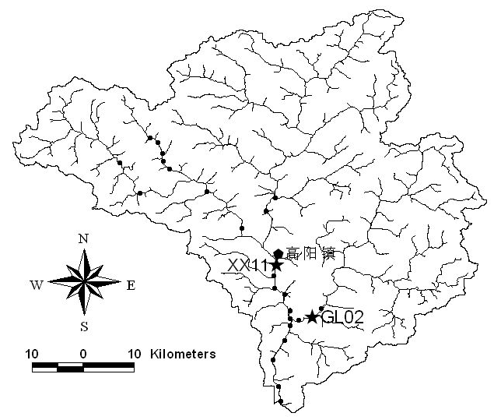
Fig.1 Sampling sites in Xiangxi River（ The sites analyzed in this paper）

Based on routine monitoring data in the Gaolan River and the main stream of Xiangxi River, this paper estimates the contribution of riverine nutrients, and analyzes the monthly variations of concentrations and loads of nutrients. The results show that Xiangxi Bay annually received 1623.49 tons of total nitrogen and 331.85 tons of total phosphorus, the main stream of Xiangxi River alone accounted for 68.5% of the total nitrogen loads and 91.74% of the total phosphorus loads; Dissolved inorganic nitrogen is the dominating form in the two rivers; Phosphate phosphorus is the dominating form in the main stream of Xiangxi River, relatively low in the Gaolan River; Nitrogen in the two rivers and phosphorus in the Gaolan River have been caused by nonpoint source emissions, while point sources of phosphorus plays an important role in the main stream of Xiangxi River; The seasonal distribution of dissolved inorganic nitrogen and total nitrogen in the two rivers exhibit that loads are high during the summer, July, then the spring and autumn, relatively low during the winter; Loads of phosphorus are high during the late spring and summer, relatively low during the low-flow late autumn and winter periods in the Gaolan River, while the phosphorus dynamics smaller amplitude over the year; The monthly variation of nitrogen concentrations in the two rivers and phosphorus concentrations in the Gaolan River during the studied period is clearly positively correlated to water discharge, while the variation of phosphorus concentrations in the main stream of Xiangxi River is not included; Losses from soils probably represented the major emissions of nonpoint source, while the drainages of phosphorus diggings and factories play the most important role in the point source of phosphorus.
This research suggests that necessary measures are urged to control the point source emissions of phosphorus in the main stream of Xiangxi River in order to protect Xiangxi Bay, the Three-Gorge Reservoir.

