Impacts of a small hydropower plant on macroinvertebrate habitat and brief discussion on ecological water requirement of Xiangxi River
Fu Xiao-Cheng, Wu Nai-Cheng, Zhou Shu-Chan, Cai Qing-Hua
State Key Laboratory of Freshwater Ecology and Biotechnology,
Institute of Hydrobiology, the Chinese Academy of Science
1. Questions involved and research background:
Ecological water demand of rivers is a research focus in water conservancy and ecology fields nowadays. Especially, with the population growth and rapid economic development, the increasing trend of utilization of water resources is seriously conflicted with the limited water supply. Hydropower generation is a common practice for utilizing water resources. However, there are hot debates behind the construction of dams in consideration of their negative impacts, such as dry-up of watercourses, deterioration of natural vegetation, soil erosion etc. Downstream of the dam there is a long segment of watercourses where the remaining flow tends to be minimal, sometimes disappearing completely. How much of the water should be left for the river and what is the minimum of the ecological water requirement? There is not a content answer still.
There are a variety of definitions and studying methods of ecological water requirement, but not a single one is adopted unanimously. As for river ecological water requirement, it refers to the water needed in maintaining and protecting the basic function of the river ecosystem, which includes the water needed in the maintenance of the habitats for the aquatic organisms and the balance of the river ecosystem.
There are about four groups of methods mostly common used in calculating the ecological water requirement.
Hydrological Methods: including 7Q10 method, Tennant method, Texas method, and Basic Flow method.
Hydraulic methods: including Wetted Perimeter Method, and R2Cross method.
Habitat Methods: including Usable Width method, Weighted Usable Width method, IFIM/PHABSIM method, and CASMIR method.
Holistic Methods: including Building Block method, and Holistic method of Australia.
2. A case study in Xiangxi River:
Xiangxi River is one of tributaries of Yangtze River in Three Gorges Region, which originates from the Shennongjia Mountain Area, passes through Xingshan Country and Zigui Country, and has a length of 94km, a catchment area of 3,099 km2, and a natural fall of 1,540 m. According to the annual report of Xinshan, there are more than 40 small hydropower plants (SHPs) built or to be building in Xiangxi River.

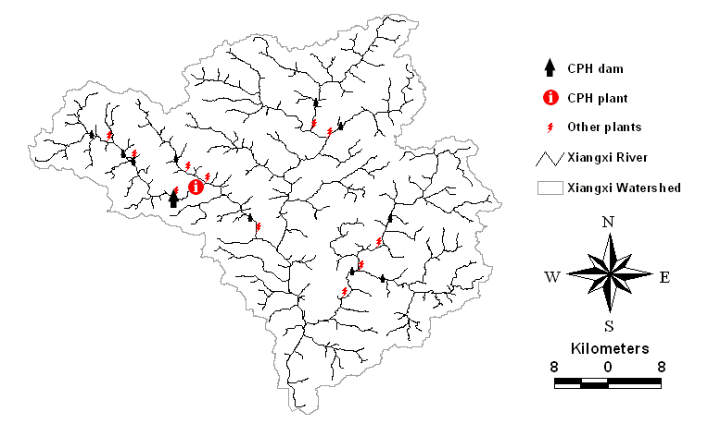

Figure 1. Research Area ― the Xiangxi River

In our study, a typical SHP named “Cangpinghe” was investigated monthly for researching the impacts of small hydropower plants on macroinvertebrate habitat and the ecological water requirement of Xiangxi River. The weighted usable widths (WUW) were calculated for three dominant orders of the macroinvertebrates (Ephemeroptera, Plecoptera and Trichoptera) at each cross section and some comparisons were conducted among cross sections. The results showed that the water diversion of the dam made part of the downstream channel dry up and the WUW of the three orders of the macroinvertebrates declined significantly from the upstream channel to the downstream channel. According to the relationship between the WUW and the river discharge, the minimum ecological water requirement for the main groups of the macroinvertebrates in Xiangxi River was about 3.8 m3/s.
3. Conclusion:
This study makes it realistic how to reasonably determine the ecological water demand of rivers, to protect ecology and environment, and how to maintain biologic diversity and ecosystem stability in the development of hydraulic engineering.
Key words: weighted usable width; ecological water requirement; macroinvertebrate; Xiangxi River

